**University timetabling (unitime) maintenance**

**Phase 2**

|  |  |
| --- | --- |
| **Name** | **ID** |
| Youssef Hussein Mahmoud | 20206111 |
| Ahmed Nasr Hassan | 20206129 |
| Omar Sayed Ramadan | 20206042 |
| Mahmoud Hassan | 20206071 |

**GitHub repository link:** <https://github.com/Youssef-Wahba/University-Timetabling-Maintaince>

**Jira Project:** https://youssefhussein1.atlassian.net/jira/core/projects/UT/board

UML diagram before resolving bugs:

UML diagram after resolving bugs:

**Static Analysis Report before changes:**

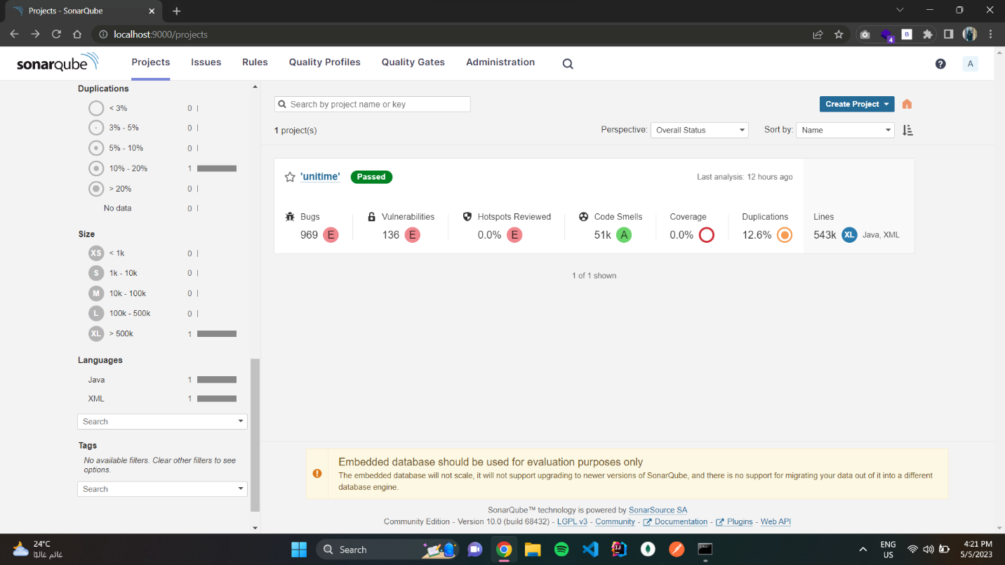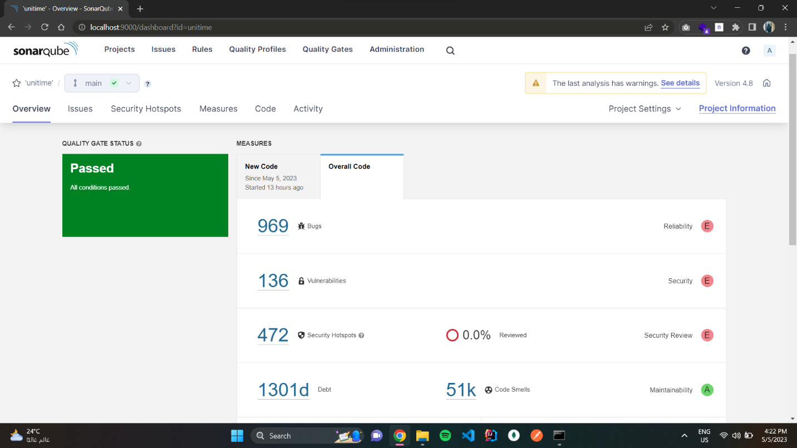

**Static Analysis Report after changes:**

**Jira issue tickets and status:**

**File 1(JavaSource/org/unitime/timetable/webutil/timegrid/ExamGridTable.java):**

**Before**

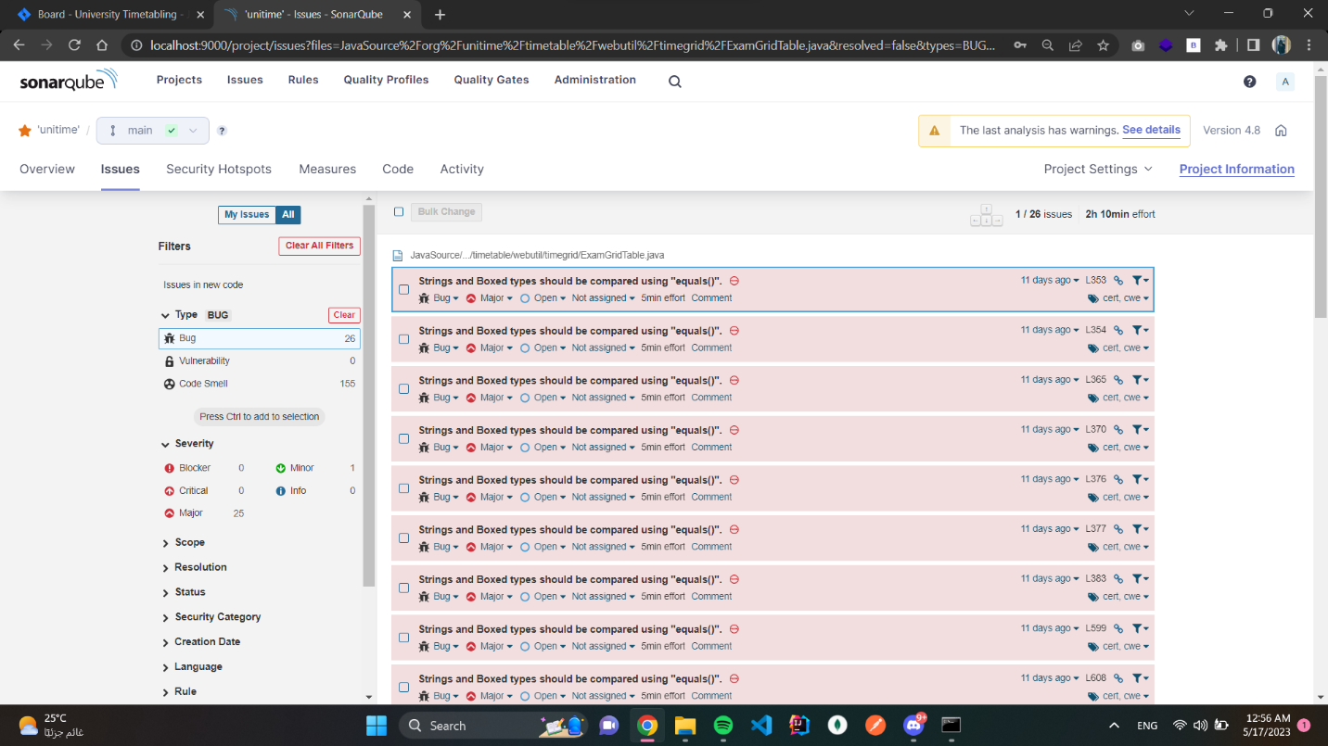

**After**

**File 2(JavaSource/org/unitime/timetable/webutil/timegrid/PdfExamGridTable.java):**

**Before**

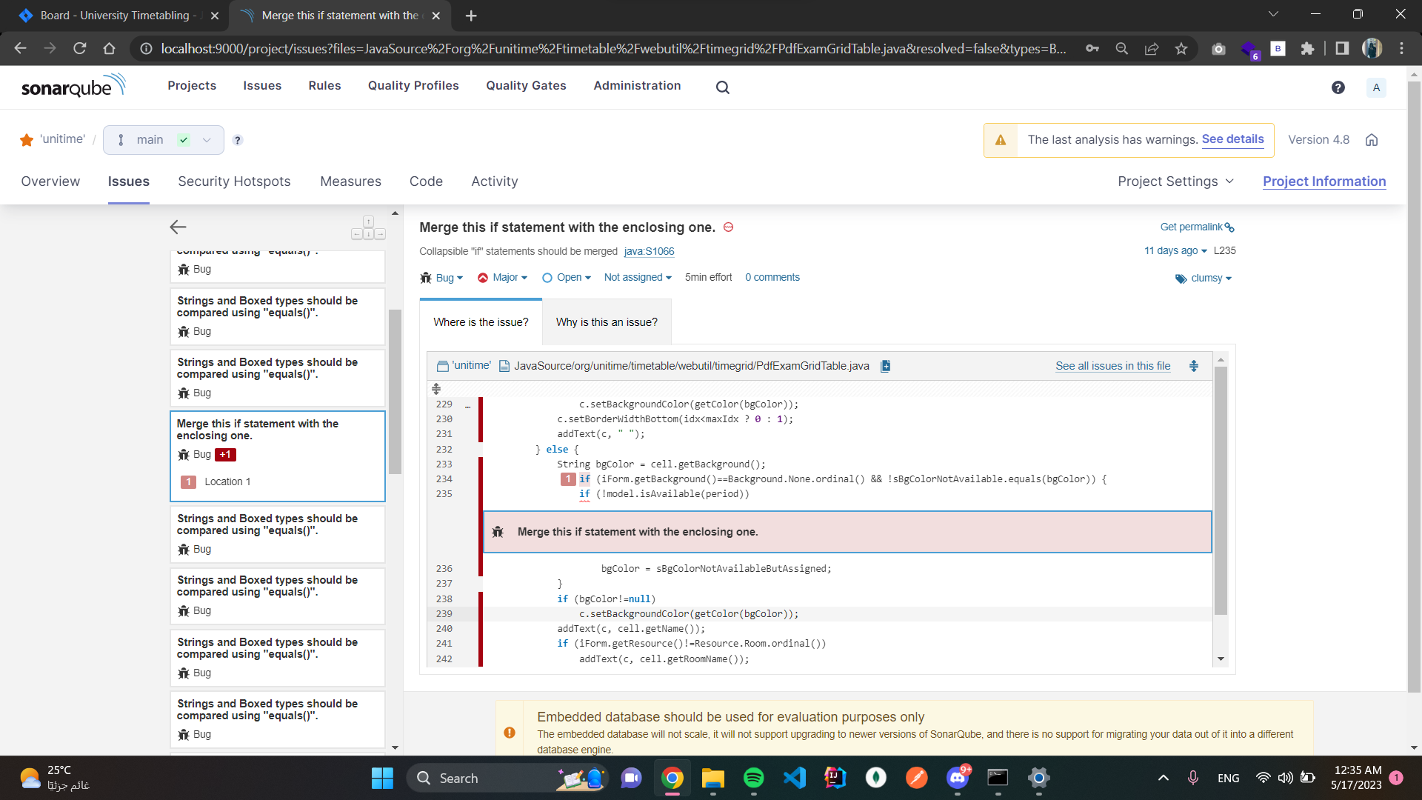

**After**

